We are trying to characterize the GCR fluxes in the near-Mars space environment (1.5 AU, inner heliosphere) and are not only considering the variabilities due to SZA, SSN, etc. but also GZA, especially since this is a factor that hasn't really been considered. The count rates measured by the MGS-ER are dependent on both solar zenith angle and sunspot number. In order to calculate a conversion factor between the MGS-ER and the MEX-ELS instrument, it is important to account for these effects so the error in translating between the two count rates is minimized. We have done this by binning both data sets with respect to sunspot number and solar zenith angle and calculating conversion factors only between each of the corresponding bins. This has yielded a table of conversion factors which more accurately put the MEX-ELS count rates in terms of the MGS-ER instrument than having only one conversion factor does. The next step would be to also bin by galactic zenith angle, in order to account for seasonal effects in the datasets and further improve our conversion factor.

We are also interested in how MGS’s orbit differs from MEX’s. There are two main differences, first, the spacecraft remains at a much lower and more fixed altitude, meaning it experiences less variability from Mars’ magnetosphere and has a near constant planetary blockage. Second, the instrument deck always remains in a fixed position pointing downward at the planet, which enables the MGS-ER to only view one side of the galaxy, the side not blocked by the planet, at a time. The combination of these two factors means that over one Martian year, the MGS-ER instrument will view every side of the galaxy in an isolated fashion, gathering high energy particle measurements without interferences which would otherwise make such a measurement impossible, such as a strong magnetic field or no planetary blockage at all. In order to use the MGS-ER as a directional detector of GCR’s, there are two variables which are useful to us, solar zenith angle and galactic zenith angle. Solar zenith angle indicates whether the spacecraft is on the dayside or the nightside of the planet, but what that really tells us is whether the MGS-ER is gathering measurements from the direction of the Sun or the direction of the rest of the galaxy. Galactic zenith angle, which we take to be the angle MGS forms with Mars and the nose of the heliosphere, then tells us which part of the galaxy Mars is seeing based on its position in solar orbit. Our work on this topic involves first eliminating all other factors, such as sunspot number, altitude, spacecraft blockage, etc. so that we may analyze the trends in the MGS-ER data with respect to only the two zenith angles. This will then allow us to characterize the variability in GCR flux from the different parts of the galaxy.

**Figure 1: MGS-ER Count Rate Dependency on SZA and GZA**

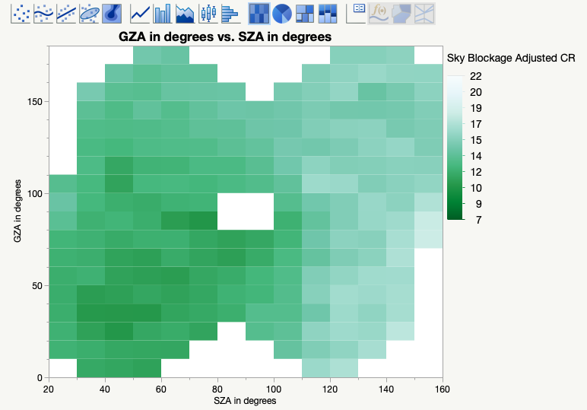

Figure 1 Caption: This figure bins data from two years of MGS’s orbit with regard to SZA and GZA. The color of each bin corresponds to the median count rate at that point in orbit. Trends in the figure indicate that at higher GZA and SZA there is a higher count rate.

**Figure 2: Nose of the Heliosphere**

Figure 2 Caption: This figure shows a map of the heliosphere with the nose indicated.